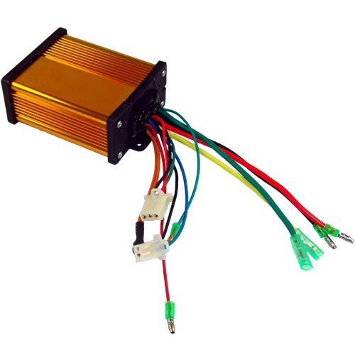
ZY-KA98 36 Volt Controller Product Specifications
Technical Parameters

Rated Voltage | 36 Volts
Rated Current † | 30 Amps
Rated Motors | ≤ 500 Watts
Rated Efficiency | 95%
Rated Charger | ≤ 3.0 Amps
Under Voltage Protection †† | 30.5 Volts ± 0.5 Volts
Dimensions | 95 x 76 x 38 mm

Wiring Specifications

Power  Connector  § - Required  Connection | 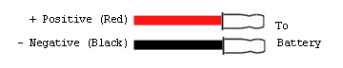
Motor  Connector  § - Required  Connection | 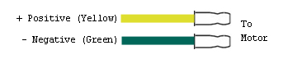
Throttle  Connector  § - Required  Connection | 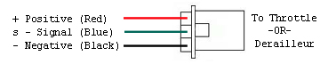
Lock  Connector  § - Required  Connection | 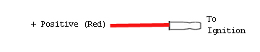
Brake  Lever  Connector | 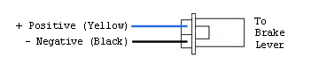

TNC Scooters
ZY-KA98 36 Volt – 2012 – TNC Scooters
†- The Rated Current prevents the motor current from exceeding the specified value avoiding damage to the motor and the controller due to over current conditions.

†† - The Under Voltage Protection circuit cuts off the battery output when battery voltage falls below the specified value.

Wiring Specifications continued on back…
Wiring Specifications – continued

§ - Connection required for the controller to function properly.
(Battery Connector, Motor Connector, Throttle Connector, Ignition Switch).
ZY-KA98 36 Volt – 2012 – TNC Scooters
Copyright © 2012 TNC Scooters LLC. All rights reserved.
NOTES
Speed  Indicator | 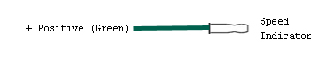
Speed  Limit  Potentiometer | 