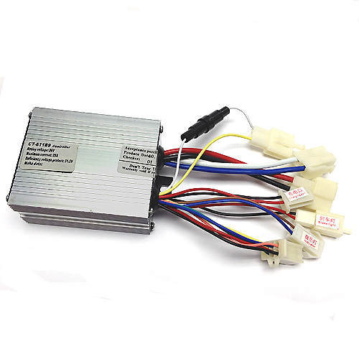
CT-611B9 36 Volt Controller Product Specifications
Technical Parameters

Rated Voltage | 36 Volts
Rated Current † | 25 Amps
Rated Motors | ≤ 500 Watts
Rated Efficiency | 95%
Rated Charger | ≤ 3.0 Amps
Under Voltage Protection †† | 30.5 Volts ± 0.5 Volts
Dimensions | 95 x 76 x 38 mm

Wiring Specifications

Power  Connector  § - Required  Connection | 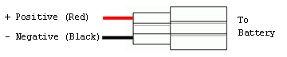
Motor  Connector  § - Required  Connection | 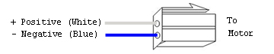
Six Wire  Connector  § - Required  Connection  SEE NOTES | 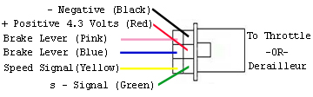
Ignition  Switch  Connector  § - Required  Connection | 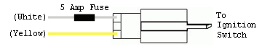

TNC Scooters
CT-611B9 36 Volt – 2012 – TNC Scooters
†- The Rated Current prevents the motor current from exceeding the specified value avoiding damage to the motor and the controller due to over current conditions.

†† - The Under Voltage Protection circuit cuts off the battery output when battery voltage falls below the specified value.

Wiring Specifications continued on back…
Wiring Specifications – continued

§ - Connection required for the controller to function properly.
(Battery Connector, Motor Connector, Throttle Connector, Ignition Switch).
CT-611B9 36 Volt – 2012 – TNC Scooters
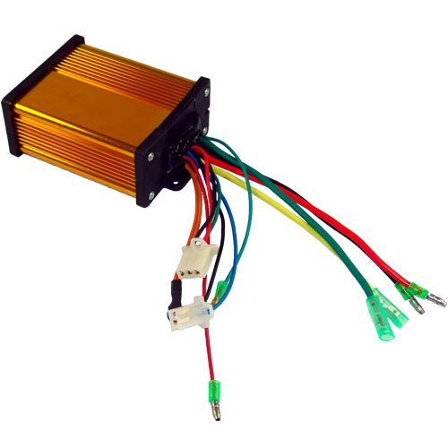
Copyright © 2012 TNC Scooters LLC. All rights reserved.
NOTES

The Six Wire Connector is a combination of the Throttle Connector, Brake Lever Connector, and the Speedometer Connector. The Throttle wires (BLACK, RED, and GREEN) are required for the controller to function properly. The Brake Lever wires (PINK and BLUE) and the Speedometer Signal wire (YELLOW) are optional connections.

WARNING
USE EXTREME CAUTION WHEN CONNECTING THE THROTTLE TO PERVENT ELECTRICAL SHORT CIRCUITS.
Charge  Connector | 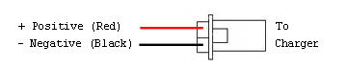
Power  Indicator  Connector | 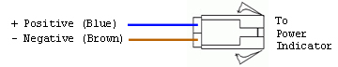
Brake Light  Connector | 